Crypt fission rate – main

We used Approximate Bayesian Computation to estimate the crypt fission rate in the human colon. We simulated a large number of colonic sites and sampled the simulated colons in the same way as the actual colon samples (Methods). We counted the number of coalescence events occurring across the whole cohort in 10 year bins to assess which values of the crypt fission rate parameter produced a similar number of coalescence events as seen in our cohort.

Under this model, we estimate the crypt fission rate in the human colon to be 0.037 (0.021 – 0.063, 95% credibility interval) crypt fissions per crypt per year. This is higher but comparable to estimates of the crypt fission rate via histological methods (<https://gut.bmj.com/content/early/2019/03/19/gutjnl-2018-317540>).

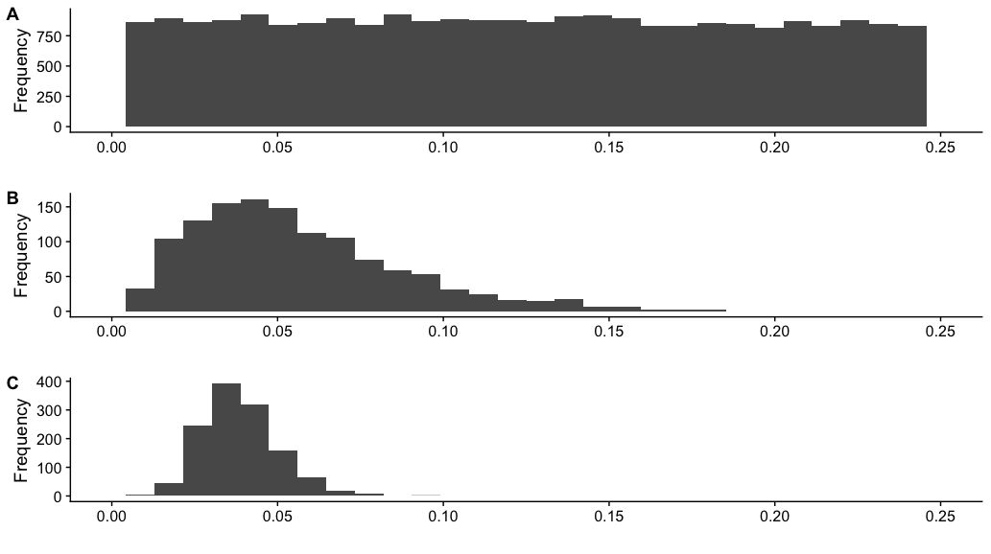

Figure caption: Approximate Bayesian computation of the crypt fission rate in the human colon. A) The prior distribution of the crypt fission rate used to simulate many biopsies of the colon. The unit for the crypt fission rate is fissions per crypt per year. B) The crypt fission rates of the 5% of simulations that produced summary statistics most similar to those calculated for the observed data. C) The posterior distribution of the crypt fission rate parameter estimated by neural network regression on the simulations in B. The 95% credibility interval is 0.021-0.063 fissions per crypt per year.